Red Bag Full of Joy Referral
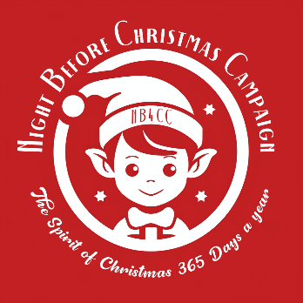
Name of referring individual:
Organisation:
Address:
Email Address:
Phone No.

Guidance for Referral

Red bags full of Joy: A bag of specially selected new items for children and young people including PJs, books, chocolate and a special item or toy. Child or young person must be vulnerable as a result of poverty. Referrals can be made from October – December by any trusted member of the community as long as checks are completed by the referrer to reduce duplicate referrals. Bags to be collected from Annbank Village Hall on an agreed date unless delivery has been agreed.

Christmas Individual Referrals: For children or young people who are going to receive nothing at Christmas as a result of financial poverty and vulnerability we are able to provide a more substantial Christmas present. Please email nb4cc2017@gmail.com to discuss this further. With all referrals we ask that families are made aware that a referral is being made to the charity on their behalf.

Mum and Baby Red Bags Full of Joy (In partnership with Feed): A bag of specially selected new items for Mums with infants aged under 12 months including PJ’s, chocolate, toiletries and something nice for Mums, plus PJ’s, vests, books and toys for the wee ones. We can also include infant feeding items including bottles, breast pads, nipple cream. We can provide first infant formula and breast pumps only if specifically requested in the ‘further information’ box.

Guidance for completion of Form

Please detail the age and sex of the children you are referring and do not provide us with any personal data. If the child is, for example, age 5-6 years but requires 6-7 pyjamas then please add them into the 5-6 years box but add a note in the space below the table for further details, telling us about the difference in size. Please also provide any information which you think is relevant for the referral such as if a child has additional needs.

Agreement

I agree that these details can be held by The Night Before Christmas Campaign as the main contact. I agree that I will provide as much detail as possible in a timely manner in order that the referral can be fulfilled by the volunteers and that where possible I will arrange collection of the items from Annbank Village Hall. Once completed please submit this form to nb4cc2017@gmail.com.

Signature ____________________________________________ Date ____________

For Office Use Only
Date Received
Date of contact made by staff
Name of Volunteer dealing with request
Referral Fulfilled
Date of Collection /Drop Off

Red Bag Full of Joy Request: Please enter the number of bags required for each age.
Age | Female | Male | Gender Neutral
0-6 months
6-12 months
12-18 months
18-24 months
2-3 years
3-4 years
4-5 years
5-6 years
6-7 years
7-8 years
8-9 years
9-10 years
10-11 years
11-12 years
12-13 years
13-14 years
14 -15 years
15 -16 years
17-18 years
18+years

Mum and Baby Red Bags Full of Joy Request:

Age of Baby | Breast Feeding | Formula Feeding | Combi Feeding
0-6 months
6-12 months

Further details: Please include details if any of the children have additional needs. Do not provide any personal data in relation to recipients.

Please send your request to nb4cc2017@gmail.com

